Customer: | Bindaree Beef |  | Date: |  | 15/01/2026
Site Address: | 4 – 6 Taree st Burliegh heads |  | Site Contact: |  | Joey Brown
 |  |  | Phone: |  | 0497622424
Customer PO #: |  |  | Internal Job #: |  | 5925
Subject: line 2
Equipment Type: |  | Serial Number: |  | Customer Line # (if applicable):
Trave 590 |  | A21A-12629 |  | Line 2
Equipment condition:
Good
Work Performed:
Travelled to site for large tool film breaking arrived on site spoke with Leno

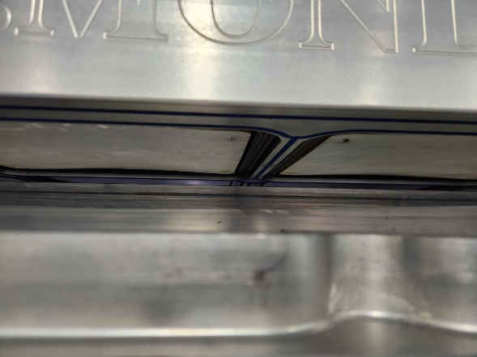
As they had some blue exit belts in stock we replace o cord with blue cord

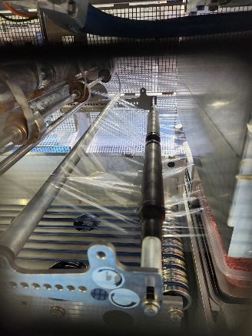
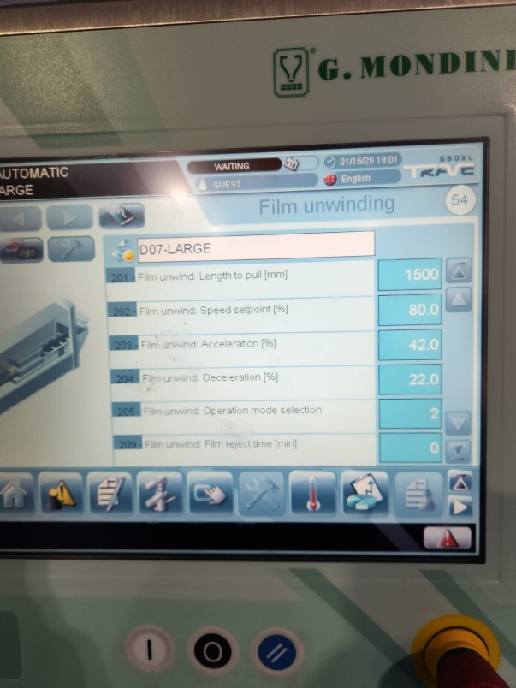
Fitted tool and watched it run working well no sticking noticed film pull almost 200 mm causing waste tried to get spreader cone operating need more time and no production.

SPARE PARTS USED
Part Number: | Description: | Qty: | Chargeable?
 |  |  | Yes ☐ | No☐
 |  |  | Yes☐ | No☐
 |  |  | Yes☐ | No☐

STATUS
Machine Tested? | Yes☐ | No☐
Comments: Good
Revisit Required? | Yes☐ | No☐
Comments:

RECOMMENDATIONS
Comments:

RECOMMENDED SPARE PARTS
Part Number: | Description: | Qty:

TECHNICIAN HOURS
Time | Start | Finish
Travel To Site: | 12:00 | 13:00
Onsite: | 13:00 | 18:30
Travel From Site: | 18:30 | 19:30
Remote assistance:
Report writing: 16/01/26 | 11:00 | 11:30
Overnight stay | ☐
Overnight stay with flights | ☐

REPORT SIGN OFF
 | Print Name: | Signature: | Date:
Customer: | Joey Brown |  | 15/01/26
Technician: | Paul Short

